

## TOLANI COLLEGE of COMMERCE (AUTONOMOUS)

150-151, Sher-E-Punjab Society Guru Gobind Singh Road, Andheri East, Mumbai, Maharashtra 400 093

## Department of B.Sc. (Information Technology)

**CERTIFICATE**

This is to certify that , bearing Roll No. have completed the practicals in the Course of in accordance with the syllabus of B.Sc. (Information Technology) Programme of Semester VI as prescribed by the Tolani College of Commerce (Autonomous) in the academic year 2024-2025.

**Internal Examiner Programme Coordinator**

**External Examiner**

**Date: College Seal**

|  |  |  |  |
| --- | --- | --- | --- |
| Sr. | Title | Date | Sign |
| 1 | Packet Tracer - Configure Cisco Routers for Syslog,  NTP, and SSH Operations |  |  |
| 2 | Packet Tracer - Configure AAA Authentication on Cisco Routers |  |  |
| 3 | Configuring Extended ACLs - Scenario 1 Configuring Extended ACLs - Scenario 2 |  |  |
| 4 | Configure IP ACLs to Mitigate Attacks. |  |  |
| 5 | Configure and Verify a Site-to-Site IPsec VPN Using CLI |  |  |

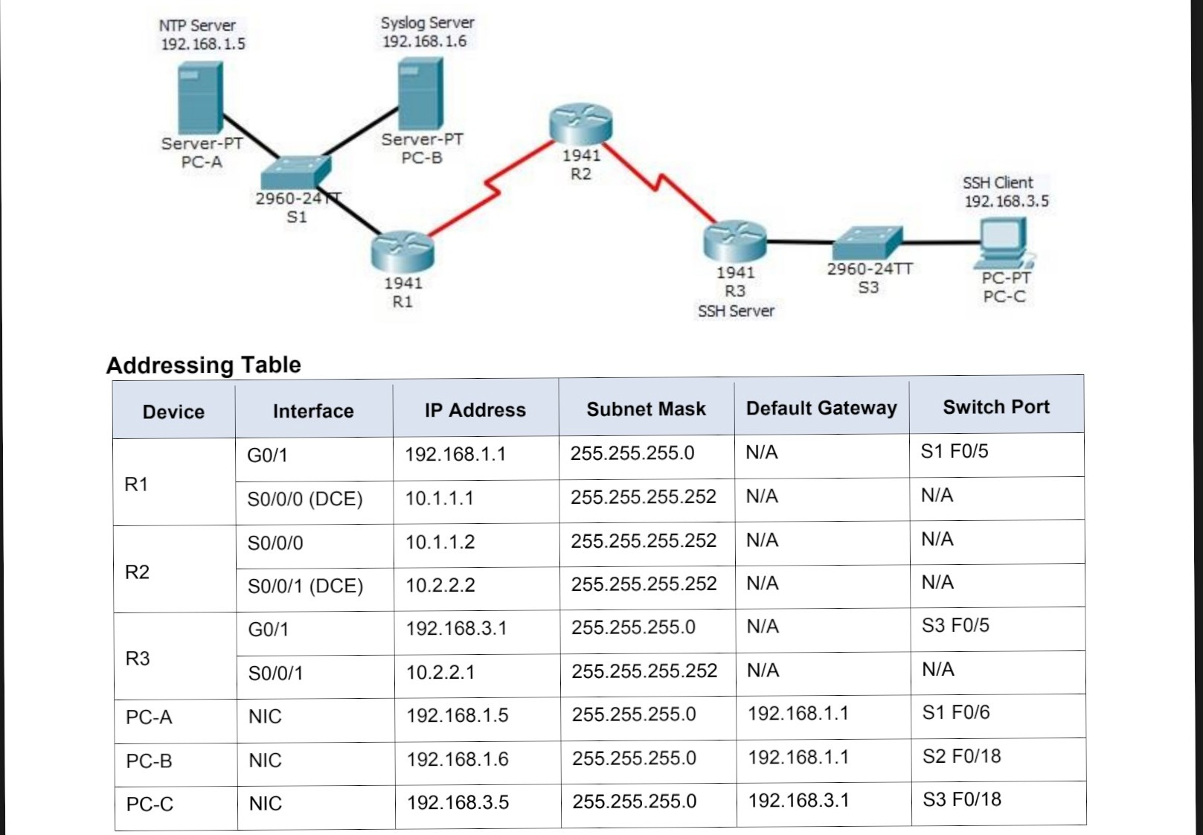

Practical 1: Packet Tracer - Configure Cisco Routers for Syslog, NTP, and SSH Operations

Topology

### Objectives

* Configure OSPF MD5 authentication.
* Configure NTP.
* Configure routers to log messages to the syslog server.
* Configure R3 to support SSH connections.

### Background / Scenario

In this activity, you will configure OSPF MD5 authentication for secure routing updates.

The NTP Server is the master NTP server in this activity. You will configure authentication on the NTP server and the routers. You will configure the routers to allow the software clock to be synchronized by NTP to thetime server. Also, you will configure the routers to periodically update the hardware clock with the time learned

from NTP.

The Syslog Server will provide message logging in this activity. You will configure the routers to identify the remote

host (Syslog server) that will receive logging messages.

You will need to configure timestamp service for logging on the routers. Displaying the correct time and date in

Syslog messages is vital when using Syslog to monitor a network.

You will configure R3 to be managed securely using SSH instead of Telnet. The servers have been preconfigured for NTP and Syslog services respectively. NTP will not require authentication. The routers have

been pre-configured with the following passwords:

* Enable password: **ciscoenpa55**
* Password for vty lines: **ciscovtypa55**

**Note**: Note: MD5 is the strongest encryption supported in the version of Packet Tracer used to develop this activity

(v6.2). Although MD5 has known vulnerabilities, you should use the encryption that meets the security requirements of your organization. In this activity, the security requirement specifies MD5.

## Part 1: Configure OSPF MD5 Authentication

#### Step 1: Test connectivity. All devices should be able to ping all other IP addresses. Step 2: Configure OSPF MD5 authentication for all the routers in area 0. Configure

OSPF MD5 authentication for all the routers in area 0.

R1(config)# **router ospf 1**

R1(config-router)# **area 0 authentication message-digest**

R2(config)# **router ospf 1**

R2(config-router)# **area 0 authentication message-digest**

R3(config)# **router ospf 1**

R3(config-router)# **area 0 authentication message-digest**

**Step 3: Configure the MD5 key for all the routers in area 0.** Configure an MD5 key on the serial interfaces on **R1**, **R2** and **R3**. Use the password **MD5pa55** for key **1**.

R1(config)# **interface s0/0/0**

R1(config-if)# **ip ospf message-digest-key 1 md5 MD5pa55**

R2(config)# **interface s0/0/0**

R2(config-if)# **ip ospf message-digest-key 1 md5 MD5pa55**

R2(config-if)# **interface s0/0/1**

R2(config-if)# **ip ospf message-digest-key 1 md5 MD5pa55**

R3(config)# **interface s0/0/1**

R3(config-if)# **ip ospf message-digest-key 1 md5 MD5pa55**

#### Step 4: Verify configurations.

a. Verify the MD5 authentication configurations using the commands **show ip ospf interface**. b. Verify end-to-end connectivity.

## Part 2: Configure NTP

#### Step 1: Enable NTP authentication on PC-A.

a. b. On **PC-A**, click **NTP** under the Services tab to verify NTP service is enabled.

To configure NTP authentication, click **Enable** under Authentication. Use key **1** and password **NTPpa55**

for authentication.

**Step 2: Configure R1, R2, and R3 as NTP clients.** R1(config)# **ntp server 192.168.1.5** R2(config)# **ntp server 192.168.1.5** R3(config)# **ntp server 192.168.1.5**

Verify client configuration using the command **show ntp status**.

**Step 3: Configure routers to update hardware clock.** Configure **R1**, **R2**, **and R3** to periodically update the hardware clock with the time learned from NTP.

R1(config)# **ntp update-calendar** R2(config)# **ntp update-calendar** R3(config)# **ntp update-calendar**

Exit global configuration and verify that the hardware clock was updated using the command **show clock**.

#### Step 4: Configure NTP authentication on the routers. Configure NTP

authentication on **R1**, **R2**, and **R3** using key **1** and password **NTPpa55**.

R1(config)# **ntp authenticate**

R1(config)# **ntp trusted-key 1**

R1(config)# **ntp authentication-key 1 md5 NTPpa55**

R2(config)# **ntp authenticate**

R2(config)# **ntp trusted-key 1**

R2(config)# **ntp authentication-key 1 md5 NTPpa55**

R3(config)# **ntp authenticate**

R3(config)# **ntp trusted-key 1**

R3(config)# **ntp authentication-key 1 md5 NTPpa55**

#### Step 5: Configure routers to timestamp log messages.

Configure timestamp service for logging on the routers. R1(config)# **service timestamps log datetime msec** R2(config)# **service timestamps log datetime msec** R3(config)# **service timestamps log datetime msec**

## Part 3: Configure Routers to Log Messages to the Syslog Server

#### Step 1: Configure the routers to identify the remote host (Syslog Server) that will receive logging messages.

R1(config)# **logging host 192.168.1.6** R2(config)# **logging host 192.168.1.6** R3(config)# **logging host 192.168.1.6**

The router console will display a message that logging has started.

#### Step 2: Verify logging configuration.

Use the command **show logging** to verify logging has been enabled.

#### Step 3: Examine logs of the Syslog Server.

From the **Services** tab of the **Syslog Server**’s dialogue box, select the **Syslog** services button. Observe the logging messages received from the routers.

**Note**: Log messages can be generated on the server by executing commands on the router. For example,

entering and exiting global configuration mode will generate an informational configuration message. You may

need to click a different service and then click **Syslog** again to refresh the message display.

## Part 4: Configure R3 to Support SSH Connections

**Step 1: Configure a domain name.** Configure a domain name of **ccnasecurity.com** on **R3**.

R3(config)# **ip domain-name ccnasecurity.com**

#### Step 2: Configure users for login to the SSH server on R3.

Create a user ID of **SSHadmin** with the highest possible privilege level and a secret password of

**ciscosshpa55**.

R3(config)# **username SSHadmin privilege 15 secret ciscosshpa55**

**Step 3: Configure the incoming vty lines on R3.** Use the local user accounts for mandatory login and validation. Accept only SSH connections.

R3(config)# **line vty 0 4**

R3(config-line)# **login local**

R3(config-line)# **transport input ssh**

**Step 4: Erase existing key pairs on R3.** Any existing RSA key pairs should be erased on the router.

R3(config)# **crypto key zeroize rsa**

**Note**: If no keys exist, you might receive this message: % No Signature RSA Keys found in configuration.

#### Step 5: Generate the RSA encryption key pair for R3.

The router uses the RSA key pair for authentication and encryption of transmitted SSH data. Configure the RSA keys with a modulus of **1024**. The default is 512, and the range is from 360 to 2048.

R3(config)# **crypto key generate rsa**

The name for the keys will be: R3.ccnasecurity.com

Choose the size of the key modulus in the range of 360 to 2048 for your General Purpose Keys. Choosing a key modulus greater than 512 may take a few minutes.

How many bits in the modulus [512]: **1024**

% Generating 1024 bit RSA keys, keys will be non-exportable...[OK]

**Note**: The command to generate RSA encryption key pairs for **R3** in Packet Tracer differs from those used in the lab.

#### Step 6: Verify the SSH configuration.

Use the **show ip ssh** command to see the current settings. Verify that the authentication timeout and retries are at their default values of 120 and 3.

#### Step 7: Configure SSH timeouts and authentication parameters.

The default SSH timeouts and authentication parameters can be altered to be more restrictive. Set the timeout to **90** seconds, the number of authentication retries to **2**, and the version to **2**.

R3(config)# **ip ssh time-out 90**

R3(config)# **ip ssh authentication-retries 2**

R3(config)# **ip ssh version 2**

Issue the **show ip ssh** command again to confirm that the values have been changed.

#### Step 8: Attempt to connect to R3 via Telnet from PC-C.

Open the Desktop of **PC-C**. Select the Command Prompt icon. From **PC-C**, enter the command to connect to

**R3** via Telnet.

PC> **telnet 192.168.3.1**

This connection should fail because **R3** has been configured to accept only SSH connections on the virtual terminal lines.

#### Step 9: Connect to R3 using SSH on PC-C.

Open the Desktop of **PC-C**. Select the Command Prompt icon. From **PC-C**, enter the command to connect to

R3 via SSH. When prompted for the password, enter the password configured for the administrator

**ciscosshpa55**.

PC> **ssh –l SSHadmin 192.168.3.1**

#### Step 10: Connect to R3 using SSH on R2.

To troubleshoot and maintain **R3**, the administrator at the ISP must use SSH to access the router CLI. From the CLI of **R2**, enter the command to connect to **R3** via SSH version **2** using the **SSHadmin** user account. When prompted for the password, enter the password configured for the administrator: **ciscosshpa55**.

R2# **ssh –v 2 –l SSHadmin 10.2.2.1**

#### Step 11: Check results.

Your completion percentage should be 100%. Click **Check Results** to view the feedback and verification of which required components have been completed.

# Practical 2: Packet Tracer - Configure AAA Authentication on Cisco Routers

### Topology

**Objectives**

AAA.

* Configure a local user account on R1 and configure authenticate on the console and vty lines using local AAA.
* Verify local AAA authentication from the R1 console and the PC-A client.
* Configure server-based AAA authentication using TACACS+.
* Verify server-based AAA authentication from the PC-B client.
* Configure server-based AAA authentication using RADIUS.
* Verify server-based AAA authentication from the PC-C client.

### Background / Scenario

The network topology shows routers R1, R2 and R3. Currently, all administrative security is based on knowledge of the enable secret password. Your task is to configure and test local and server-based AAA solutions.

You will create a local user account and configure local AAA on router R1 to test the console and vty logins.

o

User account: **Admin1** and password **admin1pa55**

You will then configure router R2 to support server-based authentication using the TACACS+ protocol. The TACACS+ server has been pre-configured with the following:

* Client: **R2** using the keyword **tacacspa55** o User account: **Admin2**

and password **admin2pa55**

Finally, you will configure router R3 to support server-based authentication using the RADIUS protocol. The RADIUS server has been pre-configured with the following:

* Client: **R3** using the keyword **radiuspa55** o User account: **Admin3**

and password **admin3pa55**

The routers have also been pre-configured with the following:

* Enable secret password: **ciscoenpa55**
* OSPF routing protocol with MD5 authentication using password:

**MD5pa55**

**Note**: The console and vty lines have not been pre-configured.

**Note**: IOS version 15.3 uses SCRYPT as a secure encryption hashing algorithm; however, the IOS version that is currently supported in Packet Tracer uses MD5. Always use the most secure option available on your equipment.

## Part 1: Configure Local AAA Authentication for Console Access on R1

#### Step 1: Test connectivity.

* Ping from **PC-A** to **PC-B**.
* Ping from **PC-A** to **PC-C**.
* Ping from **PC-B** to **PC-C**.

#### Step 2: Configure a local username on R1.

Configure a username of **Admin1** with a secret password of **admin1pa55**.

R1(config)# **username Admin1 secret admin1pa55**

#### Step 3: Configure local AAA authentication for console access on R1.

Enable AAA on R1 and configure AAA authentication for the console login to use the local database.

R1(config)# **aaa new-model**

R1(config)# **aaa authentication login default local**

#### Step 4: Configure the line console to use the defined AAA authentication method.

Enable AAA on **R1** and configure AAA authentication for the console login to use the default method list.

R1(config)# **line console 0**

R1(config-line)# **login authentication default**

#### Step 5: Verify the AAA authentication method.

Verify the user EXEC login using the local database.

R1(config-line)# **end**

%SYS-5-CONFIG_I: Configured from console by console R1# **exit**

R1 con0 is now available Press RETURN to get started.

************ AUTHORIZED ACCESS ONLY ************* UNAUTHORIZED ACCESS TO THIS DEVICE IS PROHIBITED.

User Access Verification Username: **Admin1** Password: **admin1pa55** R1>

## Part 2: Configure Local AAA Authentication for vty Lines on R1

#### Step 1: Configure domain name and crypto key for use with SSH.

1. Use ccnasecurity.com as the domain name on R1.

R1(config)# **ip domain-name ccnasecurity.com**

1. Create an RSA crypto key using 1024 bits.

R1(config)# **crypto key generate rsa**

Choose the size of the key modulus in the range of 360 to 2048 for your General Purpose Keys. Choosing a key modulus greater than 512 may take a few minutes.

How many bits in the modulus [512]: **1024**

% Generating 1024 bit RSA keys, keys will be non-exportable...[OK]

**Step 2**:

Configure a named list AAA authentication method for the vty lines on R1.

Configure a named list called **SSH-LOGIN** to authenticate logins using local AAA.

R1(config)# **aaa authentication login SSH-LOGIN local**

#### Step 3: Configure the vty lines to use the defined AAA authentication method.

Configure the vty lines to use the named AAA method and only allow SSH for remote access.

R1(config)# **line vty 0 4**

R1(config-line)# **login authentication SSH-LOGIN** R1(config-line)# **transport input ssh** R1(config-line)# **end**

#### Step 4: Verify the AAA authentication method.

Verify the SSH configuration SSH to **R1** from the command prompt of **PC-A**..

PC> **ssh –l Admin1 192.168.1.1**

Open

Password: **admin1pa55**

## Part 3: Configure Server-Based AAA Authentication Using TACACS+ on R2

#### Step 1: Configure a backup local database entry called Admin.

For backup purposes, configure a local username of **Admin2** and a secret password of **admin2pa55**.

R2(config)# **username Admin2 secret admin2pa55**

#### Step 2: Verify the TACACS+ Server configuration.

Click the TACACS+ Server. On the Services tab, click **AAA**. Notice that there is a Network configuration entry for **R2** and a User Setup entry for **Admin2**.

#### Step 3: Configure the TACACS+ server specifics on R2.

Configure the AAA TACACS server IP address and secret key on **R2**.

**Note**: The commands **tacacs-server host** and **tacacs-server key** are deprecated. Currently, Packet Tracer does not support the new command **tacacs server**.

R2(config)# **tacacs-server host 192.168.2.2** R2(config)#

**tacacs-server key tacacspa55**

#### Step 4: Configure AAA login authentication for console access on R2.

Enable AAA on **R2** and configure all logins to authenticate using the AAA TACACS+ server. If it is not available, then use the local database.

R2(config)# **aaa new-model**

R2(config)# **aaa authentication login default group tacacs+ local**

#### Step 5: Configure the line console to use the defined AAA authentication method.

Configure AAA authentication for console login to use the default AAA authentication method.

R2(config)# **line console 0**

R2(config-line)# **login authentication default**

#### Step 6: Verify the AAA authentication method.

Verify the user EXEC login using the AAA TACACS+ server.

R2(config-line)# **end**

%SYS-5-CONFIG_I: Configured from console by console R2# **exit**

R2 con0 is now available Press RETURN to get started.

************ AUTHORIZED ACCESS ONLY ************* UNAUTHORIZED ACCESS TO THIS DEVICE IS PROHIBITED.

User Access Verification Username: **Admin2** Password: **admin2pa55**

R2>

## Part 4: Configure Server-Based AAA Authentication Using RADIUS on R3

#### Step 1: Configure a backup local database entry called Admin.

For backup purposes, configure a local username of **Admin3** and a secret password of **admin3pa55**.

R3(config)# **username Admin3 secret admin3pa55**

#### Step 2: Verify the RADIUS Server configuration.

Click the RADIUS Server. On the Services tab, click **AAA**. Notice that there is a Network configuration entry for **R3** and a User Setup entry for **Admin3**.

#### Step 3: Configure the RADIUS server specifics on R3.

Configure the AAA RADIUS server IP address and secret key on **R3**.

**Note**: The commands **radius-server host** and **radius-server key** are deprecated. Currently Packet Tracer does not support the new command **radius server**.

R3(config)# **radius-server host 192.168.3.2** R3(config)#

**radius-server key radiuspa55**

#### Step 4: Configure AAA login authentication for console access on R3.

Enable AAA on **R3** and configure all logins to authenticate using the AAA RADIUS server. If it is not available,

then use the local database.

R3(config)# **aaa new-model**

R3(config)# **aaa authentication login default group radius local**

#### Step 5: Configure the line console to use the defined AAA authentication method.

Configure AAA authentication for console login to use the default AAA authentication method.

R3(config)# **line console 0**

**onfigure AAA Authentication on Cisco Routers**

R3(config-line)# **login authentication default**

#### Step 6: Verify the AAA authentication method.

Verify the user EXEC login using the AAA RADIUS server.

R3(config-line)# **end**

%SYS-5-CONFIG_I: Configured from console by console R3# **exit**

R3 con0 is now available Press RETURN to get started.

************ AUTHORIZED ACCESS ONLY ************* UNAUTHORIZED ACCESS TO THIS DEVICE IS PROHIBITED.

User Access Verification Username: **Admin3** Password: **admin3pa55** R3>

#### Step 7: Check results.

Your completion percentage should be 100%. Click **Check Results** to see feedback and verification of which required components have been completed.

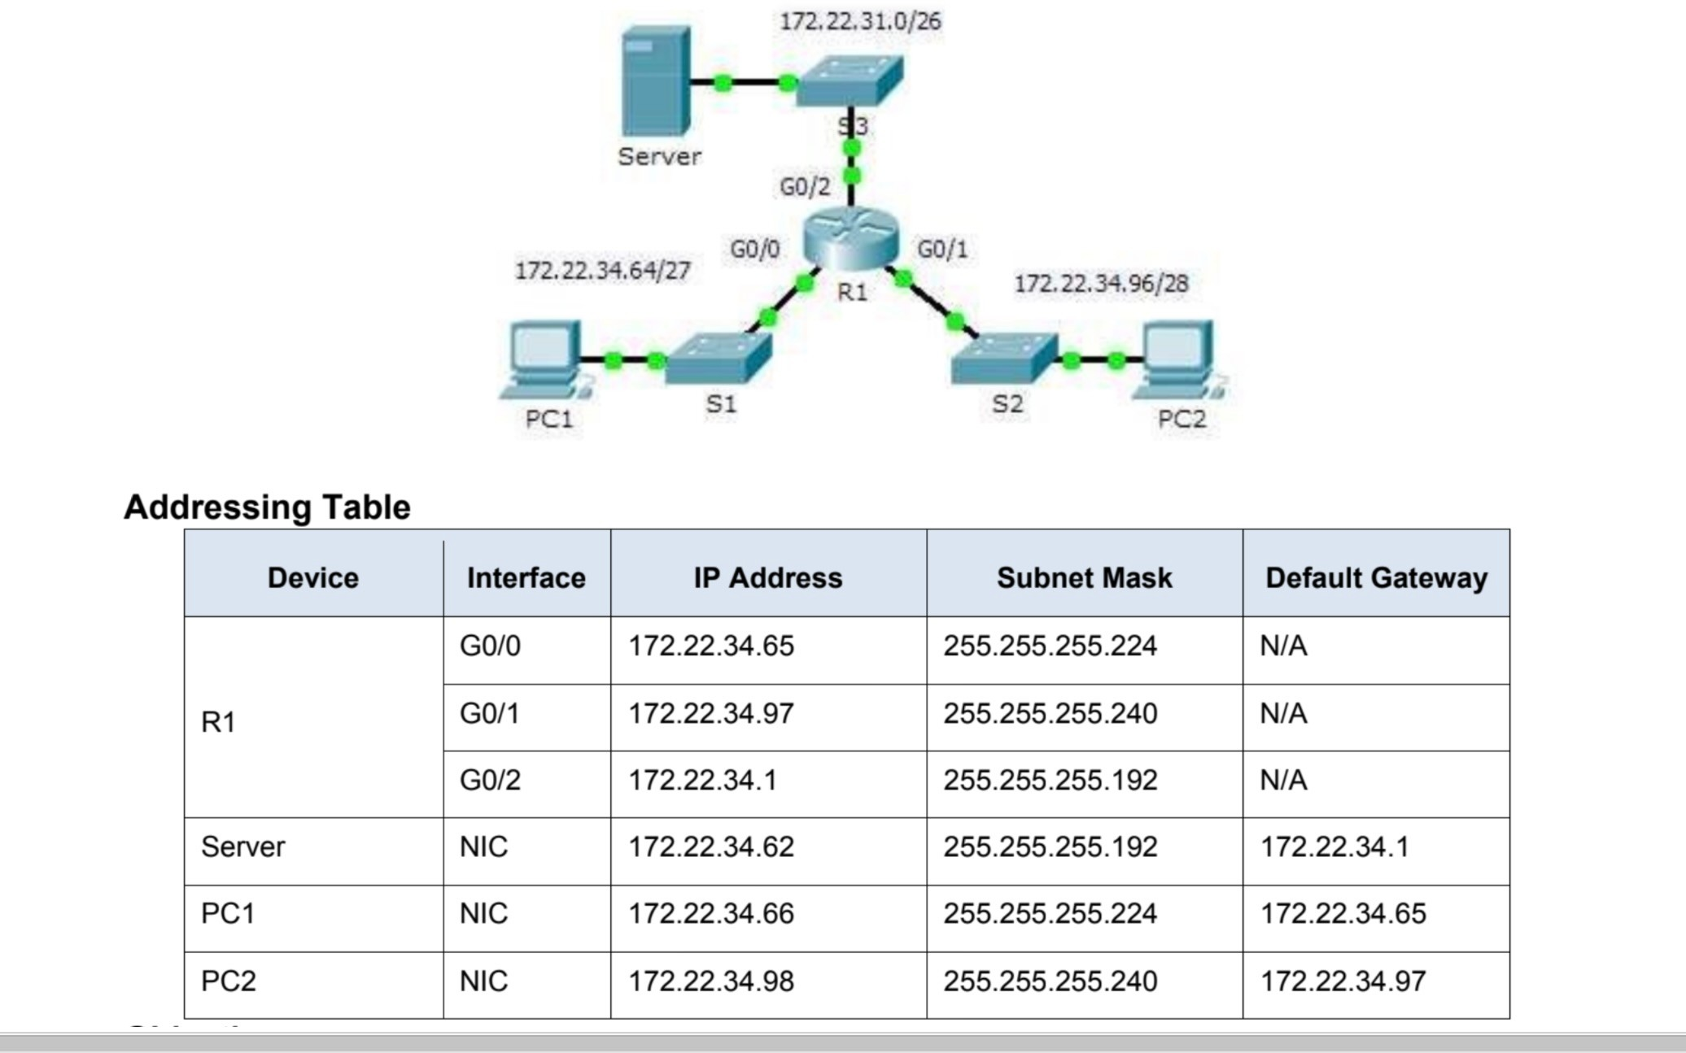

# Practical 3: Configuring Extended ACLs - Scenario 1

### Topology

**Objectives**

**Part 1: Configure, Apply and Verify an Extended Numbered ACL Part 2: Configure, Apply and Verify an Extended Named ACL**

### Background / Scenario

Two employees need access to services provided by the server. **PC1** needs only FTP access while **PC2**

needs only web access. Both computers are able to ping the server, but not each other.

## Part 1: Configure, Apply and Verify an Extended Numbered ACL

#### Step 1: Configure an ACL to permit FTP and ICMP.

1. From global configuration mode on **R1**, enter the following command to determine the first valid number for an extended access list.

R1(config)# **access-list ?**

<1-99> IP standard access list

<100-199> IP extended access list

1. Add **100** to the command, followed by a question mark.

R1(config)# **access-list 100 ?** deny Specify packets to reject permit Specify packets to forward remark Access list entry comment

1. To permit FTP traffic, enter **permit,** followed by a question mark.

R1(config)# **access-list 100 permit ?**

ahp Authentication Header Protocol eigrp Cisco's EIGRP routing protocol esp Encapsulation Security Payload gre Cisco's GRE tunneling icmp Internet Control Message Protocol ip Any Internet Protocol ospf OSPF routing protocol tcp Transmission Control Protocol udp User Datagram Protocol

1. This ACL permits FTP and ICMP. ICMP is listed above, but FTP is not, because FTP uses TCP. Therefore,enter **tcp** to further refine the ACL help.

R1(config)# **access-list 100 permit tcp ?**

A.B.C.D Source address any Any source host host A single source host

1. Notice that we could filter just for **PC1** by using the **host** keyword or we could allow **any** host. In this case, any device is allowed that has an address belonging to the 172.22.34.64/27 network. Enter the network address, followed by a question mark.

R1(config)# **access-list 100 permit tcp 172.22.34.64 ?**

A.B.C.D Source wildcard bits

1. Calculate the wildcard mask determining the binary opposite of a subnet mask.

**11111111.11111111.11111111.111**00000 = 255.255.255.224

00000000.00000000.00000000.000**11111** = 0.0.0.31

1. Enter the wildcard mask, followed by a question mark.

R1(config)# **access-list 100 permit tcp 172.22.34.64 0.0.0.31 ?**

A.B.C.D Destination address any Any destination host eq Match only packets on a given port number gt Match only packets with a greater port number host A single destination host lt Match only packets with a lower port number neq Match only packets not on a given port number range Match only packets in the range of port numbers

1. Configure the destination address. In this scenario, we are filtering traffic for a single destination, which is the server. Enter the **host** keyword followed by the server’s IP address.

R1(config)# **access-list 100 permit tcp 172.22.34.64 0.0.0.31 host 172.22.34.62**

**?**

dscp Match packets with given dscp value eq

Match only packets on a given port number established established gt Match only packets with a greater

port number number range <cr>

lt Match only packets with a lower port neq Match only packets not on a given port

number precedence Match packets with given precedence value Match only packets in the range of port numbers

1. Notice that one of the options is **<cr>** (carriage return). In other words, you can press **Enter** and the statement would permit all TCP traffic. However, we are only permitting FTP traffic; therefore, enter the **eq** keyword, followed by a question mark to display the available options. Then, enter **ftp** and press **Enter**.

R1(config)# **access-list 100 permit tcp 172.22.34.64 0.0.0.31 host 172.22.34.62 eq ?**

<0-65535> Port number ftp File

Transfer Protocol (21) pop3 Post Office Protocol v3 (110) smtp Simple Mail Transport Protocol (25) telnet Telnet (23) www World Wide Web (HTTP, 80)

R1(config)# **access-list 100 permit tcp 172.22.34.64 0.0.0.31 host**

**172.22.34.62 eq ftp**

1. Create a second access list statement to permit ICMP (ping, etc.) traffic from **PC1** to **Server**. Note that the access list number remains the same and no particular type of ICMP traffic needs to be specified. R1(config)# **access-list 100 permit icmp 172.22.34.64 0.0.0.31 host**

**172.22.34.62**

1. All other traffic is denied, by default.

#### Step 2: Apply the ACL on the correct interface to filter traffic.

From **R1**’s perspective, the traffic that ACL 100 applies to is inbound from the network connected to Gigabit Ethernet 0/0 interface. Enter interface configuration mode and apply the ACL.

R1(config)# **interface gigabitEthernet 0/0**

R1(config-if)# **ip access-group 100 in Step 3:**

#### Verify the ACL implementation

1. Ping from **PC1** to **Server**. If the pings are unsuccessful, verify the IP addresses before continuing.
2. FTP from PC1 to Server. The username and password are both cisco.

PC> ftp 172.22.34.62

1. Exit the FTP service of the **Server**.

ftp> **quit**

1. Ping from **PC1** to **PC2**. The destination host should be unreachable, because the traffic was not explicitly permitted.

## Part 2: Configure, Apply and Verify an Extended Named ACL

#### Step 1: Configure an ACL to permit HTTP access and ICMP.

1. Named ACLs start with the **ip** keyword. From global configuration mode of **R1**, enter the following command, followed by a question mark.

R1(config)# **ip access-list ?** extended Extended Access List standard Standard Access List

1. You can configure named standard and extended ACLs. This access list filters both source and destination IP addresses; therefore, it must be extended. Enter **HTTP_ONLY** as the name. (For Packet Tracer scoring, the name is case-sensitive.)

R1(config)# **ip access-list extended HTTP_ONLY**

1. The prompt changes. You are now in extended named ACL configuration mode. All devices on the **PC2**

LAN need TCP access. Enter the network address, followed by a question mark.

R1(config-ext-nacl)# **permit tcp 172.22.34.96 ?**

A.B.C.D Source wildcard bits

1. An alternative way to calculate a wildcard is to subtract the subnet mask from 255.255.255.255.

255.255.255.255

- 255.255.255.240

= 0. 0. 0. 15

R1(config-ext-nacl)# **permit tcp 172.22.34.96 0.0.0.15 ?**

1. Finish the statement by specifying the server address as you did in Part 1 and filtering **www** traffic.

R1(config-ext-nacl)# **permit tcp 172.22.34.96 0.0.0.15 host 172.22.34.62 eq www**

1. Create a second access list statement to permit ICMP (ping, etc.) traffic from **PC2** to **Server**. Note: The prompt remains the same and a specific type of ICMP traffic does not need to be specified.

R1(config-ext-nacl)# **permit icmp 172.22.34.96 0.0.0.15 host 172.22.34.62**

1. All other traffic is denied, by default. Exit out of extended named ACL configuration mode.

#### Step 2: Apply the ACL on the correct interface to filter traffic.

From **R1**’s perspective, the traffic that access list **HTTP_ONLY** applies to is inbound from the network connected to Gigabit Ethernet 0/1 interface. Enter the interface configuration mode and apply the ACL. R1(config)# **interface gigabitEthernet 0/1**

R1(config-if)# **ip access-group HTTP_ONLY in Step**

#### 3: Verify the ACL implementation.

1. Ping from **PC2** to **Server**. The ping should be successful, if the ping is unsuccessful, verify the IP addresses before continuing.
2. FTP from **PC2** to **Server**. The connection should fail.
3. Open the web browser on **PC2** and enter the IP address of **Server** as the URL. The connection should be successful.

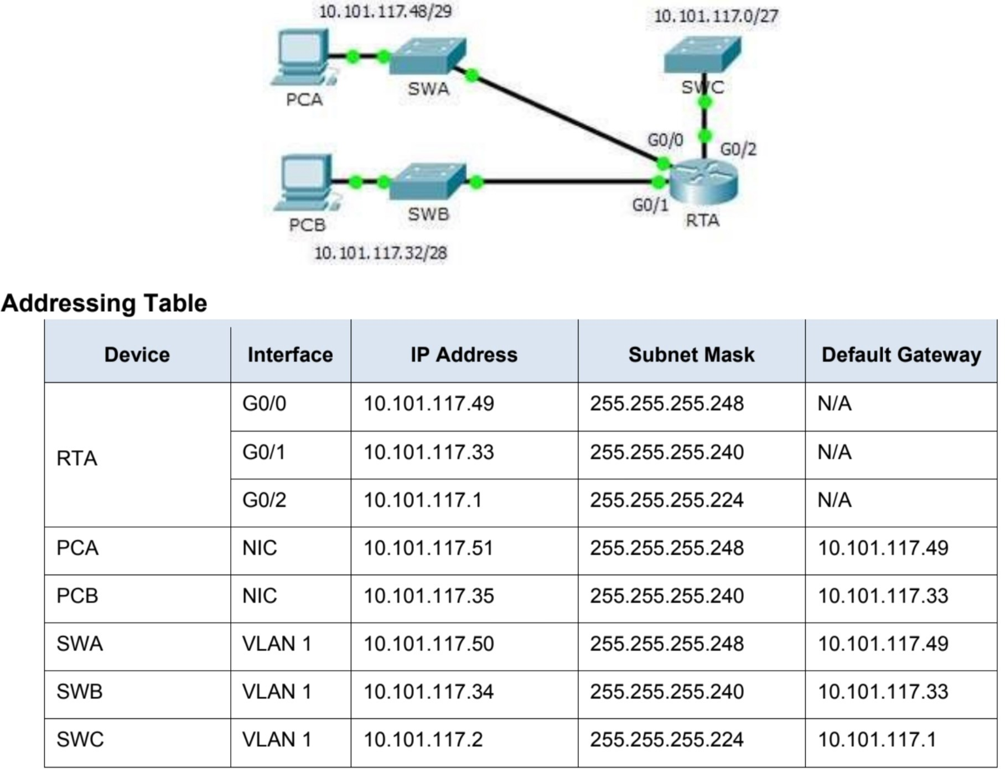

# Practical 3: Configuring Extended ACLs - Scenario 2

### Topology

**Objectives**

**Part 1: Configure, Apply and Verify an Extended Numbered ACL Part 2: Reflection Questions**

### Background / Scenario

In this scenario, devices on one LAN are allowed to remotely access devices in another LAN using the SSH protocol. Besides ICMP, all traffic from other networks is denied.

The switches and router have also been pre-configured with the following:

* Enable secret password: **ciscoenpa55**
* Console password: **ciscoconpa55**
* Local username and password: **Admin** / **Adminpa55 Packet Tracer - Configuring Extended ACLs - Scenario 2**

## Part 1: Configure, Apply and Verify an Extended Numbered ACL

Configure, apply and verify an ACL to satisfy the following policy:

* SSH traffic from devices on the 10.101.117.32/28 network is allowed to devices on the 10.101.117.0/27 networks.
* ICMP traffic is allowed from any source to any destination.
* All other traffic to 10.101.117.0/27 is blocked.

#### Step 1: Configure the extended ACL.

1. From the appropriate configuration mode on **RTA**, use the last valid extended access list number to configure the ACL. Use the following steps to construct the first ACL statement:
   1. The last extended list number is 199.
   2. The protocol is TCP.
   3. The source network is 10.101.117.32.
   4. The wildcard can be determined by subtracting 255.255.255.240 from 255.255.255.255.
   5. The destination network is 10.101.117.0.
   6. The wildcard can be determined by subtracting 255.255.255.224 from 255.255.255.255.
   7. The protocol is SSH (port 22). What is the first ACL statement?

access-list 199 permit tcp 10.101.117.32 0.0.0.15 10.101.117.0 0.0.0.31 eq 22

1. ICMP is allowed, and a second ACL statement is needed. Use the same access list number to permit all ICMP traffic, regardless of the source or destination address. What is the second ACL statement? (Hint: Use the **any** keywords)

access-list 199 permit icmp any any

1. All other IP traffic is denied, by default.

#### Step 2: Apply the extended ACL.

The general rule is to place extended ACLs close to the source. However, because access list 199 affects traffic originating from both networks 10.101.117.48/29 and 10.101.117.32/28, the best placement for this ACL might be on interface Gigabit Ethernet 0/2 in the outbound direction. What is the command to apply ACL 199 to the Gigabit Ethernet 0/2 interface?

ip access-group 199 out

#### Step 3: Verify the extended ACL implementation.

1. Ping from **PCB** to all of the other IP addresses in the network. If the pings are unsuccessful, verify the IP addresses before continuing

.

1. SSH from **PCB** to **SWC**. The username is **Admin**, and the password is **Adminpa55**.

PC> **ssh -l Admin 10.101.117.2**

1. Exit the SSH session to **SWC**.
2. Ping from **PCA** to all of the other IP addresses in the network. If the pings are unsuccessful, verify the IP addresses before continuing.
3. SSH from **PCA** to **SWC**. The access list causes the router to reject the connection.

**Packet Tracer - Configuring Extended ACLs - Scenario 2**

1. SSH from **PCA** to **SWB**. The access list is placed on **G0/2** and does not affect this connection. The username is **Admin**, and the password is **Adminpa55**.
2. After logging into **SWB**, do not log out. SSH to **SWC** in privileged EXEC mode.

SWB# **ssh -l Admin 10.101.117.2**

## Part 2: Reflection Questions

1. How was PCA able to bypass access list 199 and SSH to SWC?

Two steps were used: First, PCA used SSH to access SWB. From SWB, SSH was allowed to SWC.

1. What could have been done to prevent PCA from accessing SWC indirectly, while allowing PCB SSH access to SWC?

Because it was requested to block all traffic to 10.101.117.0/27 except SSH traffic originating from 10.101.117.32/28 the access list could be written as is. Instead of applying the ACL to G0/2 outbound apply the same ACL to both G0/0 and G0/1 inbound.

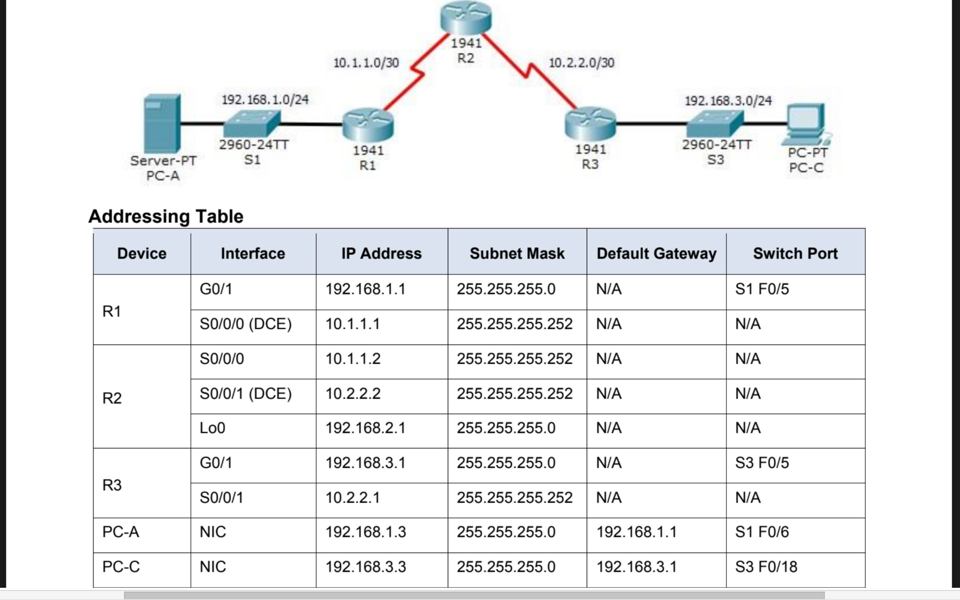

# Practical 4: Configure IP ACLs to Mitigate Attacks.

### Topology

**Objectives**

* + Verify connectivity among devices before firewall configuration.
  + Use ACLs to ensure remote access to the routers is available only from management station PC-C.
  + Configure ACLs on R1 and R3 to mitigate attacks.
  + Verify ACL functionality.

### Background/Scenario

Access to routers R1, R2, and R3 should only be permitted from PC-C, the management station. PC-C is also

used for connectivity testing to PC-A, which is a server providing DNS, SMTP, FTP, and HTTPS services. Standard operating procedure is to apply ACLs on edge routers to mitigate common threats based on source and destination IP address. In this activity, you will create ACLs on edge routers R1 and R3 to achieve this goal. You will then verify ACL functionality from internal and external hosts.

The routers have been pre-configured with the following:

* Enable password: **ciscoenpa55**
* Password for console: **ciscoconpa55**
* SSH logon username and password:

**SSHadmin**/**ciscosshpa55** o IP addressing o

Static routing

## Part 1: Verify Basic Network Connectivity

Verify network connectivity prior to configuring the IP ACLs.

#### Step 1: From PC-A, verify connectivity to PC-C and R2.

1. From the command prompt, ping **PC-C** (192.168.3.3).
2. From the command prompt, establish an SSH session to **R2** Lo0 interface (192.168.2.1) using username **SSHadmin** and password **ciscosshpa55**. When finished, exit the SSH session. SERVER> **ssh -l SSHadmin 192.168.2.1**

#### Step 2: From PC-C, verify connectivity to PC-A and R2.

1. From the command prompt, ping **PC-A** (192.168.1.3).
2. From the command prompt, establish an SSH session to **R2** Lo0 interface (192.168.2.1) using username **SSHadmin** and password **ciscosshpa55**. Close the SSH session when finished. PC> **ssh -l SSHadmin 192.168.2.1**
3. Open a web browser to the **PC-A** server (192.168.1.3) to display the web page. Close the browser when done.

## Part 2: Secure Access to Routers

**Step 1: Configure ACL 10 to block all remote access to the routers except from PC-C.** Use the **access-list** command to create a numbered IP ACL on **R1**, **R2**, and **R3**.

R1(config)# **access-list 10 permit host 192.168.3.3**

R2(config)# **access-list 10 permit host 192.168.3.3**

R3(config)# **access-list 10 permit host 192.168.3.3**

**Step 2: Apply ACL 10 to ingress traffic on the VTY lines.** Use the **access-class**

command to apply the access list to incoming traffic on the VTY lines.

R1(config-line)# **access-class 10 in** R2(config-line)# **access-class 10 in** R3(config-line)# **access-class 10 in**

#### Step 3: Verify exclusive access from management station PC-C.

1. Establish an SSH session to 192.168.2.1 from **PC-C** (should be successful).

PC> **ssh –l SSHadmin 192.168.2.1**

1. Establish an SSH session to 192.168.2.1 from **PC-A** (should fail).

## Part 3: Create a Numbered IP ACL 120 on R1

Create an IP ACL numbered 120 with the following rules:

* Permit any outside host to access DNS, SMTP, and FTP services on server

**PC-A.**

* Deny any outside host access to HTTPS services on **PC-A.**

oPermit **PC-C** to access **R1** via SSH.

**Note**: Check Results will not show a correct configuration for ACL 120 until you modify it in Part 4.

#### Step 1: Verify that PC-C can access the PC-A via HTTPS using the web browser.

Be sure to disable HTTP and enable HTTPS on server **PC-A**.

#### Step 2: Configure ACL 120 to specifically permit and deny the specified traffic.

Use **t**he access-list command to create a numbered IP ACL.

R1(config)# **access-list 120 permit udp any host 192.168.1.3 eq domain** R1(config)# **access-list 120 permit tcp any host 192.168.1.3 eq smtp** R1(config)# **access-list 120 permit tcp any host 192.168.1.3 eq ftp** R1(config)# **access-list 120 deny tcp any host 192.168.1.3 eq 443** R1(config)# **access-list 120 permit tcp host 192.168.3.3 host 10.1.1.1 eq 22**

**Step 3: Apply the ACL to interface S0/0/0.** Use the **ip access-group** command to apply the

access list to incoming traffic on interface S0/0/0. R1(config)# **interface s0/0/0** R1(config-if)# **ip access-group 120 in**

#### Step 4: Verify that PC-C cannot access PC-A via HTTPS using the web browser.

**Part 4: Modify an Existing ACL on R1**

Permit ICMP echo replies and destination unreachable messages from the outside network (relative to **R1**). Deny all other incoming ICMP packets.

#### Step 1: Verify that PC-A cannot successfully ping the loopback interface on R2.

**Step 2: Make any necessary changes to ACL 120 to permit and deny the specified traffic.**

Use the access-list command to create a numbered IP ACL. R1(config)# **access-list 120 permit icmp any any echo-reply** R1(config)# **access-list 120 permit icmp any any unreachable** R1(config)# **access-list 120 deny icmp any any**

R1(config)# **access-list 120 permit ip any any**

#### Step 3: Verify that PC-A can successfully ping the loopback interface on R2.

**Part 5: Create a Numbered IP ACL 110 on R3**

Deny all outbound packets with source address outside the range of internal IP addresses on **R3**.

**Step 1: Configure ACL 110 to permit only traffic from the inside network.** Use the **access-list** command to create a numbered IP ACL.

R3(config)# **access-list 110 permit ip 192.168.3.0 0.0.0.255 any**

**Step 2: Apply the ACL to interface G0/1.** Use the **ip access-group** command to apply the access list to incoming traffic on interface G0/1.

R3(config)# **interface g0/1**

R3(config-if)# **ip access-group 110 in**

## Part 6: Create a Numbered IP ACL 100 on R3

On **R3**, block all packets containing the source IP address from the following pool of addresses: any RFC 1918 private addresses, 127.0.0.0/8, and any IP multicast address. Since **PC-C** is being used for remote administration, permit SSH traffic from the 10.0.0.0/8 network to return to the host **PC-C**.

#### Step 1: Configure ACL 100 to block all specified traffic from the outside network.

You should also block traffic sourced from your own internal address space if it is not an RFC 1918 address. In this activity, your internal address space is part of the private address space specified in RFC 1918. Use the **access-list** command to create a numbered IP ACL. **access-list 100 permit tcp 10.0.0.0**

R3(config)#

**0.255.255.255 eq 22 host**

**192.168.3.3**

R3(config)# **access-list 100 deny ip 10.0.0.0 0.255.255.255 any**

R3(config)# **access-list 100 deny ip 172.16.0.0 0.15.255.255 any**

R3(config)# **access-list 100 deny ip 192.168.0.0 0.0.255.255 any**

R3(config)# **access-list 100 deny ip 127.0.0.0 0.255.255.255 any**

R3(config)# **access-list 100 deny ip 224.0.0.0 15.255.255.255 any** R3(config)#

**access-list 100 permit ip any any**

**Step 2: Apply the ACL to interface Serial 0/0/1.** Use the **ip access-group** command to apply the access list to incoming traffic on interface Serial 0/0/1.

R3(config)# **interface s0/0/1**

R3(config-if)# **ip access-group 100 in**

#### Step 3: Confirm that the specified traffic entering interface Serial 0/0/1 is handled correctly.

1. From the PC-C command prompt, ping the PC-A server. The ICMP echo replies are blocked by the ACL since they are sourced from the 192.168.0.0/16 address space.
2. Establish an SSH session to 192.168.2.1 from **PC-C** (should be successful).

#### Step 4: Check results.

Your completion percentage should be 100%. Click **Check Results** to see feedback and verification of which required components have been completed.

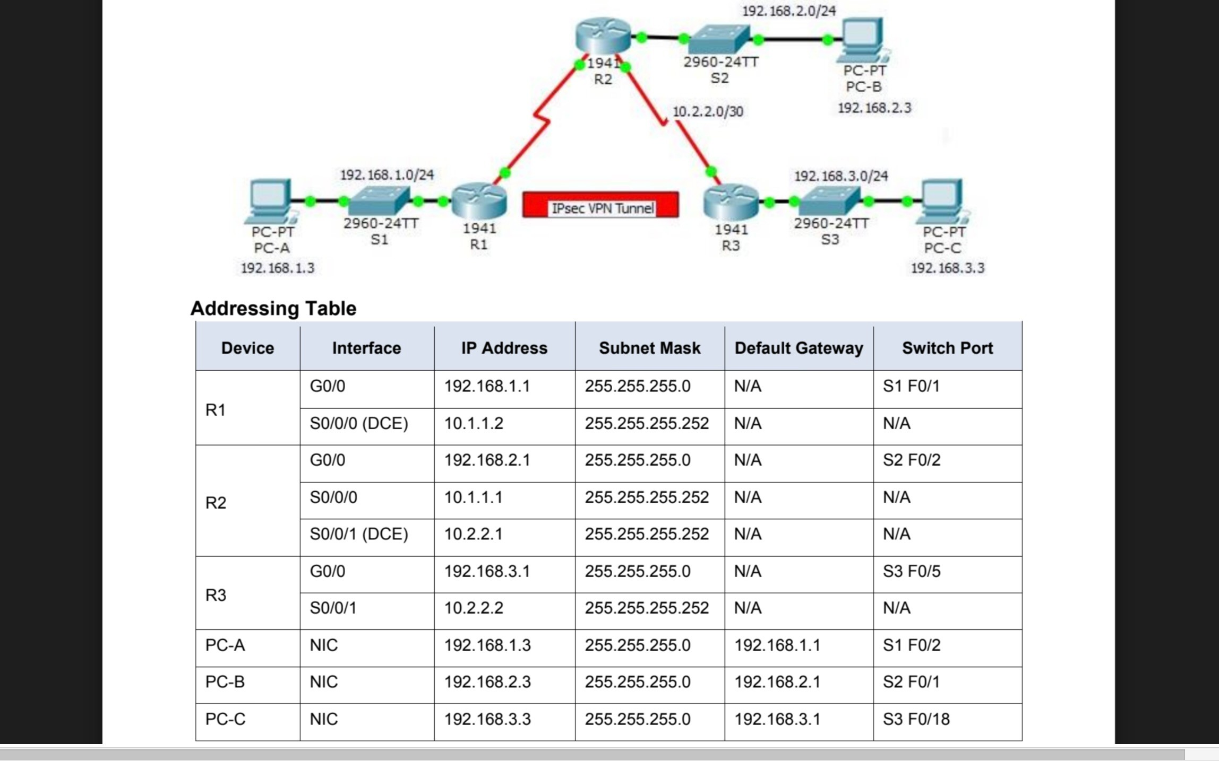

# Practical 5: Configure and Verify a Site-to-Site IPsec VPN Using CLI

### Topology

**Objectives**

* Verify connectivity throughout the network.
* Configure R1 to support a site-to-site IPsec VPN with R3.

### Background / Scenario

The network topology shows three routers. Your task is to configure R1 and R3 to support a site-to-site IPsec VPN when traffic flows between their respective LANs. The IPsec VPN tunnel is from R1 to R3 via R2. R2 acts as a pass-through and has no knowledge of the VPN. IPsec provides secure transmission of sensitive information over unprotected networks, such as the Internet. IPsec operates at the network layer and protects

and authenticates IP packets between participating IPsec devices (peers), such as Cisco routers. **ISAKMP**

## Part 1: Configure IPsec Parameters on R1

#### Step 1: Test connectivity.

**Ping from PC-A to PC-C.**

**Step 2: Enable the Security Technology package.**

## Part 2: Configure ASA Settings and Interface Security Using the CLI

**Tip**: Many ASA CLI commands are similar to, if not the same, as those used with the Cisco IOS CLI. In addition, the process of moving between configuration modes and submodes is essentially the same.

#### Step 1: Configure the hostname and domain name.

1. Configure the ASA hostname as **CCNAS-ASA**.
2. Configure the domain name as **ccnasecurity.com**.

#### Step 2: Configure the enable mode password.

Use the **enable password** command to change the privileged EXEC mode password to **ciscoenpa55**.

#### Step 3: Set the date and time.

Use the **clock set** command to manually set the date and time (this step is not scored).

#### Step 4: Configure the inside and outside interfaces.

You will only configure the VLAN 1 (inside) and VLAN 2 (outside) interfaces at this time. The VLAN 3 (dmz) interface will be configured in Part 5 of the activity.

1. Configure a logical VLAN 1 interface for the inside network (192.168.1.0/24) and set the security level to the highest setting of 100.

CCNAS-ASA(config)# **interface vlan 1** CCNAS-ASA(config-if)#

**nameif inside**

CCNAS-ASA(config-if)# **ip address 192.168.1.1 255.255.255.0** CCNAS-ASA(config-

if)# **security-level 100**

1. Create a logical VLAN 2 interface for the outside network (209.165.200.224/29), set the security level to the lowest setting of 0, and enable the VLAN 2 interface.

CCNAS-ASA(config-if)# **interface vlan 2**

CCNAS-ASA(config-if)# **nameif outside**

CCNAS-ASA(config-if)# **ip address 209.165.200.226 255.255.255.248** CCNAS-

ASA(config-if)# **security-level 0**

1. Use the following verification commands to check your configurations:
   1. Use the **show interface ip brief** command to display the status for all ASA interfaces. **Note**: This command is different from the IOS command **show ip interface brief**. If any of the physical or logical interfaces previously configured are not up/up, troubleshoot as necessary before continuing.

**Tip**: Most ASA **show** commands, including **ping**, **copy**, and others, can be issued from within any configuration mode prompt without the **do** command.

* 1. 3) Use the **show ip address** command to display the information for the Layer 3 VLAN interfaces. Use the **show switch vlan** command to display the inside and outside VLANs configured on the ASA and to display the assigned ports.

#### Step 5: Test connectivity to the ASA.

1. You should be able to ping from PC-B to the ASA inside interface address (192.168.1.1). If the pings fail, troubleshoot the configuration as necessary.
2. From PC-B, ping the VLAN 2 (outside) interface at IP address 209.165.200.226. You should not be able to ping this address.

## Part 3: Configure Routing, Address Translation, and Inspection Policy Using the CLI

#### Step 1: Configure a static default route for the ASA.

Configure a default static route on the ASA outside interface to enable the ASA to reach external networks.

1. Create a “quad zero” default route using the **route** command, associate it with the ASA outside interface, and point to the R1 G0/0 IP address (209.165.200.225) as the gateway of last resort.

CCNAS-ASA(config)# **route outside 0.0.0.0 0.0.0.0 209.165.200.225**

1. Issue the **show route** command to verify the static default route is in the ASA routing table.
2. Verify that the ASA can ping the R1 S0/0/0 IP address 10.1.1.1. If the ping is unsuccessful, troubleshoot as necessary.

#### Step 2: Configure address translation using PAT and network objects.

1. Create network object **inside-net** and assign attributes to it using the **subnet** and **nat** commands.

CCNAS-ASA(config)# **object network inside-net**

CCNAS-ASA(config-network-object)# **subnet 192.168.1.0 255.255.255.0**

CCNAS-ASA(config-network-object)# **nat (inside,outside) dynamic interface**

CCNAS-ASA(config-network-object)# **end**

1. The ASA splits the configuration into the object portion that defines the network to be translated and the actual **nat** command parameters. These appear in two different places in the running configuration. Display the NAT object configuration using the **show run** command.
2. From PC-B attempt to ping the R1 G0/0 interface at IP address 209.165.200.225. The pings should fail.
3. Issue the **show nat** command on the ASA to see the translated and untranslated hits. Notice that, of the pings from PC-B, four were translated and four were not. The outgoing pings (echos) were translated and sent to the destination. The returning echo replies were blocked by the firewall policy. You will configure the default inspection policy to allow ICMP in Step 3 of this part of the activity.

#### Step 3: Modify the default MPF application inspection global service policy.

For application layer inspection and other advanced options, the Cisco MPF is available on ASAs.

The Packet Tracer ASA device does not have an MPF policy map in place by default. As a modification, we can create the default policy map that will perform the inspection on inside-to-outside traffic. When configured

correctly only traffic initiated from the inside is allowed back in to the outside interface. You will need to add ICMP to the inspection list.

1. Create the class-map, policy-map, and service-policy. Add the inspection of ICMP traffic to the policy map list using the following commands:

CCNAS-ASA(config)# **class-map inspection_default**

CCNAS-ASA(config-cmap)# **match default-inspection-traffic**

CCNAS-ASA(config-cmap)# **exit**

CCNAS-ASA(config)# **policy-map global_policy** CCNAS-ASA(config-pmap)# **class inspection_default** CCNAS-ASA(config-pmap-c)# **inspect icmp**

CCNAS-ASA(config-pmap-c)# **exit**

CCNAS-ASA(config)# **service-policy global_policy global**

1. From PC-B, attempt to ping the R1 G0/0 interface at IP address 209.165.200.225. The pings should be successful this time because ICMP traffic is now being inspected and legitimate return traffic is being allowed. If the pings fail, troubleshoot your configurations.

## Part 4: Configure DHCP, AAA, and SSH

#### Step 1: Configure the ASA as a DHCP server.

1. Configure a DHCP address pool and enable it on the ASA inside interface.

CCNAS-ASA(config)# **dhcpd address 192.168.1.5-192.168.1.36 inside**

1. (Optional) Specify the IP address of the DNS server to be given to clients.

CCNAS-ASA(config)# **dhcpd dns 209.165.201.2 interface inside**

1. Enable the DHCP daemon within the ASA to listen for DHCP client requests on the enabled interface (inside).

CCNAS-ASA(config)# **dhcpd enable inside**

1. Change PC-B from a static IP address to a DHCP client, and verify that it receives IP addressing information. Troubleshoot, as necessary to resolve any problems.

#### Step 2: Configure AAA to use the local database for authentication.

1. Define a local user named **admin** by entering the **username** command. Specify a password of

**adminpa55**.

CCNAS-ASA(config)# **username admin password adminpa55**

1. Configure AAA to use the local ASA database for SSH user authentication.

CCNAS-ASA(config)# **aaa authentication ssh console LOCAL**

#### Step 3: Configure remote access to the ASA.

The ASA can be configured to accept connections from a single host or a range of hosts on the inside or outside network. In this step, hosts from the outside network can only use SSH to communicate with the ASA.

SSH sessions can be used to access the ASA from the inside network.

1. Generate an RSA key pair, which is required to support SSH connections. Because the ASA device has RSA keys already in place, enter **no** when prompted to replace them.

CCNAS-ASA(config)# **crypto key generate rsa modulus 1024**

WARNING: You have a RSA keypair already defined named <Default-RSA-Key>.

1. c. Do you really want to replace them? [yes/no]: **no**

ERROR: Failed to create new RSA keys named <Default-RSA-Key>

Configure the ASA to allow SSH connections from any host on the inside network (192.168.1.0/24) and from the remote management host at the branch office (172.16.3.3) on the outside network. Set the SSH timeout to 10 minutes (the default is 5 minutes).

CCNAS-ASA(config)# **ssh 192.168.1.0 255.255.255.0 inside**

CCNAS-ASA(config)# **ssh 172.16.3.3 255.255.255.255 outside** CCNAS-ASA(config)#

**ssh timeout 10**

1. Establish an SSH session from PC-C to the ASA (209.165.200.226). Troubleshoot if it is not successful.

PC> **ssh -l admin 209.165.200.226**

1. Establish an SSH session from PC-B to the ASA (192.168.1.1). Troubleshoot if it is not successful.

PC> **ssh -l admin 192.168.1.1**

## Part 5: Configure a DMZ, Static NAT, and ACLs

R1 G0/0 and the ASA outside interface already use 209.165.200.225 and .226, respectively. You will use public address 209.165.200.227 and static NAT to provide address translation access to the server.

#### Step 1: Configure the DMZ interface VLAN 3 on the ASA.

1. Configure DMZ VLAN 3, which is where the public access web server will reside. Assign it IP address 192.168.2.1/24, name it **dmz**, and assign it a security level of 70. Because the server does not need to initiate communication with the inside users, disable forwarding to interface VLAN 1.

CCNAS-ASA(config)# **interface vlan 3**

CCNAS-ASA(config-if)# **ip address 192.168.2.1 255.255.255.0** CCNAS-

ASA(config-if)# **no forward interface vlan 1** CCNAS-ASA(config-if)#

**nameif dmz**

INFO: Security level for "dmz" set to 0 by default. CCNAS-

ASA(config-if)# **security-level 70**

1. Assign ASA physical interface E0/2 to DMZ VLAN 3 and enable the interface.

CCNAS-ASA(config-if)# **interface Ethernet0/2**

CCNAS-ASA(config-if)# **switchport access vlan 3**

1. Use the following verification commands to check your configurations:
   1. Use the **show interface ip brief** command to display the status for all ASA interfaces.
   2. Use the **show ip address** command to display the information for the Layer 3 VLAN interfaces.
   3. Use the **show switch vlan** command to display the inside and outside VLANs configured on the ASA and to display the assigned ports.

#### Step 2: Configure static NAT to the DMZ server using a network object.

Configure a network object named **dmz-server** and assign it the static IP address of the DMZ server (192.168.2.3). While in object definition mode, use the **nat** command to specify that this object is used to translate a DMZ address to an outside address using static NAT, and specify a public translated address of 209.165.200.227.

CCNAS-ASA(config)# **object network dmz-server**

CCNAS-ASA(config-network-object)# **host 192.168.2.3**

CCNAS-ASA(config-network-object)# **nat (dmz,outside) static 209.165.200.227**

CCNAS-ASA(config-network-object)# **exit**

#### Step 3: Configure an ACL to allow access to the DMZ server from the Internet.

Configure a named access list **OUTSIDE-DMZ** that permits the TCP protocol on port 80 from any external host to the internal IP address of the DMZ server. Apply the access list to the ASA outside interface in the “IN”

direction.

CCNAS-ASA(config)# **access-list OUTSIDE-DMZ permit icmp any host 192.168.2.3** CCNAS-ASA(config)# **access-list OUTSIDE-DMZ permit tcp any host 192.168.2.3 eq 80**

CCNAS-ASA(config)# **access-group OUTSIDE-DMZ in interface outside**

**Note**: Unlike IOS ACLs, the ASA ACL permit statement must permit access to the internal private DMZ address. External hosts access the server using its public static NAT address, the ASA translates it to the internal host IP address, and then applies the ACL.

#### Step 4: Test access to the DMZ server.

At the time this Packet Tracer activity was created, the ability to successfully test outside access to the DMZ web server was not in place; therefore, successful testing is not required.

#### Step 5: Check results.

Your completion percentage should be 100%. Click **Check Results** to see feedback and verification of which required components have been completed.

**Practical 6: Configuring a Zone-Based Policy Firewall (ZPF)**

**Topology**

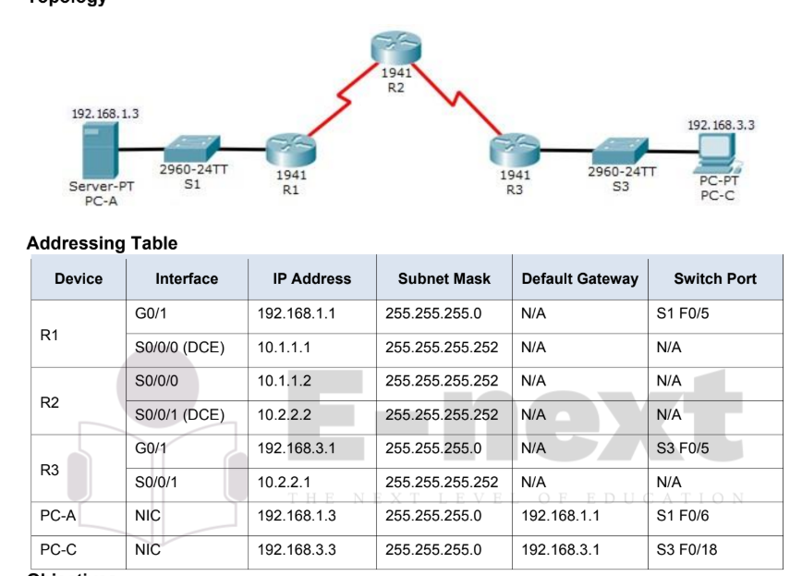

**Objectives**

• Verify connectivity among devices before firewall configuration.

• Configure a zone-based policy (ZPF) firewall on R3.

• Verify ZPF firewall functionality using ping, SSH, and a web browser.

**Background/Scenario**

ZPFs are the latest development in the evolution of Cisco firewall technologies. In this activity, you will

configure a basic ZPF on an edge router R3 that allows internal hosts access to external resources and

blocks external hosts from accessing internal resources. You will then verify firewall functionality from internal

and external hosts.

**The routers have been pre-configured with the following:**

o Console password: **ciscoconpa55**

o Password for vty lines: **ciscovtypa55** o Enable password: **ciscoenpa55**

o Host names and IP addressing o Local username and password:

**Admin / Adminpa55** o Static routing

Part 1: Verify Basic Network Connectivity

Verify network connectivity prior to configuring the zone-based policy firewall.

**Step 1**: From the PC-A command prompt, ping PC-C at 192.168.3.3.

**Step 2**: Access R2 using SSH.

a. From the PC-C command prompt, SSH to the S0/0/1 interface on R2 at 10.2.2.2. Use the username

Admin and password Adminpa55 to log in. PC> ssh -l Admin 10.2.2.2

b. Exit the SSH session.

**Step 3**: From PC-C, open a web browser to the PC-A server.

a. Click the Desktop tab and then click the Web Browser application. Enter the PC-A IP address

192.168.1.3 as the URL. The Packet Tracer welcome page from the web server should be displayed. b.

Close the browser on PC-C.

**Part 2:** Create the Firewall Zones on R3

Note: For all configuration tasks, be sure to use the exact names as specified.

**Step 1**: Enable the Security Technology package.

a. On R3, issue the show version command to view the Technology Package license information.

b. If the Security Technology package has not been enabled, use the following command to enable the

package.

**R3(config)#** **license boot module c1900 technology-package securityk9**

c. Accept the end-user license agreement.

d. Save the running-config and reload the router to enable the security license.

e. Verify that the Security Technology package has been enabled by using the show version command.

Step 2: Create an internal zone. Use the zone security command

to create a zone named IN-ZONE. **R3(config)# zone security**

**IN-ZONE**

R3(config-sec-zone) **exit**

Step 3: Create an external zone. Use the zone security command to

create a zone named OUT-ZONE.

R3(config-sec-zone)# **zone security OUT-ZONE** R3(config-sec-

zone)# **exit**

**Part 3: Identify Traffic Using a Class-Map**

Step 1: Create an ACL that defines internal traffic.

Use the access-list command to create extended ACL 101 to permit all IP protocols from the 192.168.3.0/24

source network to any destination.

R3(config)# **access-list 101 permit ip 192.168.3.0 0.0.0.255 any**

**Step 2: Create a class map referencing the internal traffic ACL.**

**Use the class-map type inspect command with the match-all option to create a class map named IN-**

**NETCLASS-MAP. Use the match access-group command to match ACL 101.**

**R3(config)# class-map type inspect match-all IN-NET-CLASS-MAP**

**R3(config-cmap)# match access-group 101**

**R3(config-cmap)# exit**

**Part 4: Specify Firewall Policies**

**Step 1: Create a policy map to determine what to do with matched traffic. Use the**

**policy-map type inspect command and create a policy map named IN-2-OUT-PMAP.**

**R3(config)# policy-map type inspect IN-2-OUT-PMAP**

**Step 2: Specify a class type of inspect and reference class map IN-NET-CLASS-MAP.**

**R3(config-pmap)# class type inspect IN-NET-CLASS-MAP**

**Step 3: Specify the action of inspect for this policy map.**

**The use of the inspect command invokes context-based access control (other options include pass and**

**drop).**

**R3(config-pmap-c)# inspect**

**%No specific protocol configured in class IN-NET-CLASS-MAP for inspection. All**

**protocols will be inspected. Issue the exit command twice to leave config-pmap-c mode and**

**return to config mode.**

**R3(config-pmap-c)# exit**

**R3(config-pmap)# exit**

**Part 5: Apply Firewall Policies**

**Step 1: Create a pair of zones.**

**Using the zone-pair security command, create a zone pair named IN-2-OUT-ZPAIR. Specify the source and**

**destination zones that were created in Task 1.**

**R3(config)# zone-pair security IN-2-OUT-ZPAIR source IN-ZONE destination**

**OUTZONE**

**Step 2: Specify the policy map for handling the traffic between the two zones.**

**Attach a policy-map and its associated actions to the zone pair using the service-policy type inspect**

**command and reference the policy map previously created, IN-2-OUT-PMAP.**

**R3(config-sec-zone-pair)# service-policy type inspect IN-2-OUT-PMAP**

**R3(config-sec-zone-pair)# exit**

**R3(config)#**

**Step 3: Assign interfaces to the appropriate security zones.**

Use the zone-member security command in interface configuration mode to assign G0/1 to IN-ZONE and

S0/0/1 to OUT-ZONE.

R3(config)# interface g0/1

R3(config-if)# zone-member security IN-ZONE

R3(config-if)# exit

R3(config)# interface s0/0/1

R3(config-if)# zone-member security OUT-ZONE R3(config-if)#

exit

Step 4: Copy the running configuration to the startup configuration.

Part 6: Test Firewall Functionality from IN-ZONE to OUT-ZONE

Verify that internal hosts can still access external resources after configuring the ZPF.

Step 1: From internal PC-C, ping the external PC-A server.

From the PC-C command prompt, ping PC-A at 192.168.1.3. The ping should succeed.

Step 2: From internal PC-C, SSH to the R2 S0/0/1 interface.

a. From the PC-C command prompt, SSH to R2 at 10.2.2.2. Use the username Admin and the password

Adminpa55 to access R2. The SSH session should succeed.

b. While the SSH session is active, issue the command show policy-map type inspect zone-pair

sessions on R3 to view established sessions.

R3# show policy-map type inspect zone-pair sessions

policy exists on zp IN-2-OUT-ZPAIR

Zone-pair: IN-2-OUT-ZPAIR

Service-policy inspect : IN-2-OUT-PMAP

Class-map: IN-NET-CLASS-MAP (match-all)

Match: access-group 101

Inspect

Number of Established Sessions = 1

Established Sessions

Session 175216232 (192.168.3.3:1028)=>(10.2.2.2:22) tcp SIS_OPEN/TCP_ESTAB

Created 00:00:25, Last heard 00:00:20

Bytes sent (initiator:responder) [1195:1256]

Class-map: class-default (match-any)

Match: any

Drop (default action)

0 packets, 0 bytes

What is the source IP address and port number?

192.168.3.3:1028 (port 1028 is random)

What is the destination IP address and port number?

___________________________________________________________________________________

_

10.2.2.2:22 (SSH = port 22)

Step 3: From PC-C, exit the SSH session on R2 and close the command prompt window.

Step 4: From internal PC-C, open a web browser to the PC-A server web page.

Enter the server IP address 192.168.1.3 in the browser URL field, and click Go. The HTTP session should

succeed. While the HTTP session is active, issue the command show policy-map type inspect zone-pair

sessions on R3 to view established sessions.

Note: If the HTTP session times out before you execute the command on R3, you will have to click the Go

button on PC-C to generate a session between PC-C and PC-A.

R3# show policy-map type inspect zone-pair sessions

policy exists on zp IN-2-OUT-ZPAIR

Zone-pair: IN-2-OUT-ZPAIR

Service-policy inspect : IN-2-OUT-PMAP

Class-map: IN-NET-CLASS-MAP (match-all)

Match: access-group 101

Inspect

Number of Established Sessions = 1

Established Sessions

Session 565266624 (192.168.3.3:1031)=>(192.168.1.3:80) tcp SIS_OPEN/TCP_ESTAB

Created 00:00:01, Last heard 00:00:01

Bytes sent (initiator:responder) [284:552]

Class-map: class-default (match-any)

Match: any

Drop (default action)

0 packets, 0 bytes

What is the source IP address and port number?

_______________________________________________________________________________________

192.168.3.3:1031 (port 1031 is random)

What is the destination IP address and port number?

_______________________________________________________________________________________

192.168.1.3:80 (HTTP web = port 80)

Step 5: Close the browser on PC-C.

Part 7: Test Firewall Functionality from OUT-ZONE to IN-ZONE

Verify that external hosts CANNOT access internal resources after configuring the ZPF.

Step 1: From the PC-A server command prompt, ping PC-C.

From the PC-A command prompt, ping PC-C at 192.168.3.3. The ping should fail.

Step 2: From R2, ping PC-C.

From R2, ping PC-C at 192.168.3.3. The ping should fail.

Step 3: Check results.

Your completion percentage should be 100%. Click Check Results to see feedback and verification of which

required components have been completed.

**prac 2 do almost in every router so that msg will pass forwards and backwards both**

in every router CLI put this

this is Router 2 ka but same fo R1 AND R3 ALSO . Write each command one by one

R2>en

R2#conf t

Enter configuration commands, one per line. End with CNTL/Z.

R2(config)#line vty 0 4

R2(config-line)#password admin

R2(config-line)#login

R2(config-line)#en

% Ambiguous command: "en"

R2(config)#router ospf 2

R2(config-router)#network 192.168.2.0 0.0.0.255 area 0

R2(config-router)#network 10.2.2.0 0.0.0.255 area 0

R2(config-router)#network 10.1.1.0 0.0.0.255 area 0

R3>en

R3#conf t

Enter configuration commands, one per line. End with CNTL/Z.

R3(config)#line vty 0 4

R3(config-line)#password login

R3(config-line)#en

% Ambiguous command: "en"

R3(config)#router ospf 3

R3(config-router)#network 192.168.3.0 0.0.0.255 area 0

R3(config-router)#network 10.2.2.0 0.0.0.255 area 0